A Project Report on

**EXPLORATORY DATA ANALYSIS ON OTT MEDIA**

**USING ML TOOL**

**Submitted to**



**SRI PADMAVATHI MAHILA VISVAVIDYALAYAM,TIRUPATI**

For partial fulfillment of M.Sc Statistics

Submitted by

PONAKALAPALLI SRAVANI

P.MOUNIKA

R.JAYASRI

SAI SRI PRAVALLIKA.D

VELASIRIHARIKA

VUNTLA SANDHYA

P.BHAVYA

**Under the Guidance of**

Ms. A. VANI M.Sc.,

**DEPARTMENT OF STATISTICS**

**SRI PADMAVATHI MAHILA VISVAVIDYALAYAM,**

**TIRUPATI**

**OCTOBER,2023**

**CERTIFICATE**

This is to certify that the project on **“ EXPLORATORY DATA ANALYSIS ON OTT MEDIA USING ML TOOL”** is a bonafide record of work done by  **P.SRAVANI , P.MOUNIKA , R.JAYASRI , SAI SRI PRAVALLIKA.D , V.HARIKA , V.SANDHYA , P.BHAVYA** of M.Sc., Statistics , **Department of Statistics, Sri Padmavati Mahila Visvavidyalayam , Tirupati** for partial fulfillment of the requirement for the award of M.Sc., Statistics Degree.

Place :

Date :

Project Guide Head of the department

Ms.A.VANI M.Sc Dr M. SIVA PARVATHI

Department of Statistics HEAD I/c

SPMVV SPMVV

TIRUPATI TIRUPATI

Signature of the Examiner

**DECLARATION**

We here by declare that the results embodied in this dessertation entitled

**“ EXPLORATORY DATA ANALYSIS ON OTT MEDIA”** is carried out by us under the guidence of **MS. A.VANI,** during the period from June 2023 to September 2023 in a partial fulfillment of the degree of M.Sc., Statistics from **SRI PADMAVATI MAHILA VISVAVIDYALAYAM, TIRUPATI.** This work is purely a new contribution by us and it was not used any where earlier for the purpose of award of any degree or diploma.

Place : **TIRUPATI**

Date :

|  |  |  |  |
| --- | --- | --- | --- |
| **S.No** | **NAME** | **HALL TICKET**  **NUMBER** | **SIGNATURE** |
| **1** | **P.SRAVANI** | **2021SAT95036** |  |
| **2** | **P.MOUNIKA** | **2021SAT95037** |  |
| **3** | **R.JAYASRI** | **2021SAT95039** |  |
| **4** | **SAI SRI PRAVALLIKA.D** | **2021SAT95040** |  |
| **5** | **V.HARIKA** | **2021SAT95041** |  |
| **6** | **V.SANDHYA** | **2021SAT95042** |  |
| **7** | **P.BHAVYA** | **2020SAT95039** |  |

**ACKNOWLEDGMENT**

Our sincere thanks and gratefulness to our project guide **Ms. A. VANI, M.Sc.,** Department of statistics, School of sciences, Tirupati, for her commitment and able guidance in the successful completion of the project work.

We express our deep of gratitude to **Dr. M. SIVA PARVATHI**, Head I/c, Department of Statistics, School of Sciences, SPMVV, Tirupati, for her encouragement and support.

We express our deep sense of gratitude to **Associate Prof. Dr. R. VISHNU VARDHAN** Department of Statistics, Pondicherry University, Pondicherry, to have unique Opportunity and the privilege of working with sincere under his guidance. We warmly acknowledge his kind support, encouragement, and valuable suggestions throughout the course of study through pragmatic, incisive, radial, innovative approach.

Our Sincere thanks to our faculty members for their support and encouragement. We thank the non-teaching staff for their timely help.

We are benevolent and beholden to our parents for their scintillating support to complete this project.

We thank the university authorities for providing necessary infrastructure facilities and support.

**P. SRAVANI**

**P. MOUNIKA**

**R. JAYA SRI**

**SAI SRI PRAVALLIKA.D**

**V. HARIKA**

**V. SANDHYA**

**P. BHAVYA**

|  |  |  |
| --- | --- | --- |
| **S.NO.** | **CONTENT** | **PAGE NO.** |
| **1** | **INTRODUCTION** |  |
| **2** | **OBJECTIVES** |  |
| **3** | **METHODOLOGY** |  |
| **4** | **REVIEW OF LITERATURE** |  |
| **5** | **DATA COLLECTION** |  |
| **6** | **ABOUT THE SOFTWARE** |  |
| **7** | **STATISTICAL TOOLS USED UNDER STUDY** |  |
| **8** | **EXPERIMENTAL RESULTS** |  |
| **9** | **CONCLUSION** |  |
| **10** | **REFERENCE** |  |

**TABLE OF CONTENT**

**CHAPTER – 01**

**INTRODUCTION**

**OTT (Over The Top)**

OTT Platforms stands for Over The Top Platforms with the diverse taste and preference of the people. OTT Platforms have become popular these days. Those days are gone when people rely on Television to broadcast their favourite show. People nowadays subscribe to OTT platforms. Users select the genre they like and start watching the content of their choice. The covid-19 pandemic and lockdown have forced people to stay at home. With colleges, offices, and theatres shut down; people rely completely on the OTT platforms for entertainment.

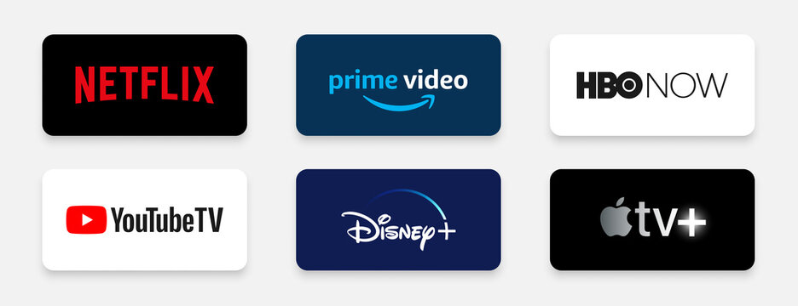

**WHAT IS OTT PLATFORM**

OTT platforms stream audio and video services through the internet. Many of the OTT platforms offer some content for free and charge some content. The user has to buy a subscription to the charged content to be able view it. Subscription is usually charged for content unique to the platform which is not available on the other platforms.

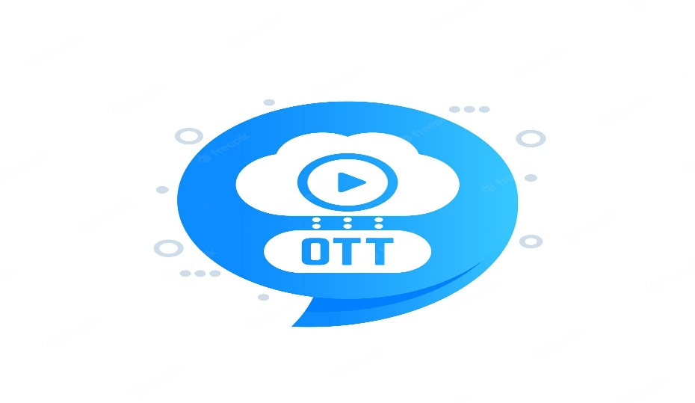

The OTT platforms are technically advance and use artificial intelligence to provide a better experience to the user. Using artificial intelligence, the content which the user is likely to watch is shown based on the previous content viewed by the user. This gives the user an advantage of personalized suggestions based on the history of content they like and are interested in.

**HISTORY OF OTT PLATFORMS IN INDIA**

OTT platforms started in India with BigFlix. Launched by Reliance Entertainment in 2008, BigFix became India's first OTT platform. Eventually, OTT started thriving in India in 2013 after the launch of Zee TV and Sony Liv. Disney Hotstar came into the OTT world in 2015. Viewers of Disney Hotstar are increasing since its launch. Today, it has become one of the most-watched OTT platforms. Later, Netflix began providing its service in India from the beginning of 2016 and competing with the platforms like Amazon-Prime Video and Disney+Hotstar.

**NETFLIX**

Netflix has been a game-changer in the streaming industry, so there's plenty of material to delve into. It has a huge library of movies and shows, so they have a wide screening capacity. You can find something for every mood and interest! Advantages of Netflix include a wide variety of movies, TV shows, and documentaries available for streaming, the convenience of watching anytime and anywhere, and the option to create personalized profiles for different family members. Some possible disadvantages of Netflix can include the cost of a subscription, limited availability of certain movies or TV shows, and occasional buffering or streaming issues. Netflix has encountered on its journey to becoming a global entertainment powerhouse. It will analyse issue to content creation, diversity and inclusion, competition, regulatory concerns and the sustainability of its business model.

In recent years, the company has faced increasing competition from other streaming services, but it continues to invest heavily in original programming and expand its global reach, making it a dominant force in the entertainment industry. Netflix's innovative approach to content delivery and its commitment to producing high-quality original content have solidified its position as a powerhouse in the ever-evolving world of entertainment.

**AHA**



Aha is an Indian over-the-top (OTT) streaming platform that has rapidly gained popularity as a go-to destination for streaming a diverse range of content, primarily catering to the Telugu-speaking audience. Launched in February 2020, aha has quickly established itself as a prominent player in the competitive Indian streaming industry. The platform offers a rich and varied library of movies, web series, and original content, making it a one-stop hub for entertainment in the Telugu language.

Aha boasts a collection of Telugu movies spanning various genres, from action-packed blockbusters to thought-provoking dramas and romantic comedies. In addition to movies, Aha has invested heavily in producing original web series, ensuring that viewers have a steady stream of engaging and binge-worthy content.

Aha understands the evolving preferences of its audience and strives to cater to their needs, ensuring that viewers can enjoy their favourite content on their terms. Whether you're a fan of Telugu cinema or simply interested in exploring a diverse world of entertainment, Aha has emerged as a compelling streaming option, bringing the best of Telugu entertainment to audiences around the world.

**AMAZON PRIME VIDEO**



Amazon Prime Video is a popular online streaming service offered by Amazon.com. It provides subscribers with access to a vast library of movies, TV shows, original content, and other video content for a monthly or annual subscription fee. Amazon prime video is available in many countries around the world and is accessible through various devices, including smartphones, tablets, smart TVs, and gaming consoles.

Here are some key features and offerings of Amazon Prime Video:

**Library of content**: Amazon Prime Video offers a wide selection of movies, TV shows, documentaries, and original programming. This includes popular series like “The Marvelous Mrs. Maisel,” “The Boys,” and “Fleabag,” as well as a catalog of classic and recent movies.

**Original Content**: Amazon has produced a growing number of original series and movies known as Amazon Originals. These exclusive titles are only available on Amazon Prime Video and have garnered critical acclaim.

**Offline Viewing**: Subscribers can download selected titles to watch offline,which is convenient for viewing content while travelling or without a reliable internet connection

**Multiple profiles**: Amazon Prime video allows users to create multiple profiles within a single account , making it easy for family members to have their own personalized viewing experience.

**SONY LIV**



Sony LIV is a popular digital entertainment platform and streaming service owned and operated by Sony Pictures Networks India. Launched in 2013, Sony LIV has established itself as a prominent player in the Indian digital content landscape, offering a wide range of entertainment content to its users.

Sony LIV provides a diverse and extensive library of content, including movies, TV shows, sports events, web series, and original programming across various genres such as drama, comedy, thriller, sports, and more. Users can access this content on a variety of devices, including smartphones, tablets, smart TVs, and desktop computers, making it a convenient and flexible option for entertainment consumption.

One of the standout features of Sony LIV id its offering of live streaming for a wide array of sporting events, including cricket, football, tennis, and more. This has it made it a popular choice among sports enthusiasts who want to watch their favourite teams and tournaments in real-time.



Disney**+** Hotstar is a streaming platform that combines the content of Disney, Pixar, Marvel, Star Wars, and national Geographic, along with a wide range of local and regional content in some countries. Here are some key points to consider in a review:

Content variety: Disney+ Hotstar offers a diverse library of content, catering to various age groups and interest. It has a substantial collection of classic and new Disney movies and shows, making it a go-to platform for Disney fans.

Exclusive Content: The service features exclusive original content, including new shows and movies based on popular franchises like star wars and the Marvel Cinematic Universe. These exclusives can be a significant draw for subscribers.

Regional Content: In some countries, Disney+ Hotstar provides access to a wide range of local and regional content, including Bollywood and other regional language films and TV shows.

Sports Streaming: In certain markets, Disney+ Hotstar offers live sports streaming, including cricket and other popular sports events. This can be a major selling point for sports enthusiasts.

Family-Friendly: Disney+ Hotstar is known for its family-friendly content, making it a suitable option for households with children.

**OBJECTIVES**

**OBJECTIVES**

1. To Measure the Pattern of use of OTT platforms among society.
2. To determine the Factors influencing the use of OTT platforms.
3. To Recognise popular OTT platforms and content preference of viewers in OTT platforms.
4. To understand the experience of OTT platforms.

**METHODOLOGY**

**METHODOLOGY**

* Enter the data in Excel and save it.
* In R-studio can import the data by click on import dataset from excel

Browse the data import.

* In R-studio provides a built-in view () function that opens a spreadsheet-like viewer for the dataset, allowing you to explore it interactively.
* Use the summary () function to generate basic summary statistics (minimum, 1st quartile, median, mean,3rd quartile, maximum) for a data frame.
* Use the pie () function to create the pie chart. We can customize the appearance of the pie chart by adding parameters to the pie () function.

**Col** -Specify a vector of colors for each slice.

**Main** -Add a title to your pie chart.

**Legend** -This code adds a legend to the top-right corner of the plot with labels and corresponding colors.

* Use the bar plot () function to create a bar chart in R. We can customize the appearance of bar chart by adding parameters to bar plot ()

**Col-** Specify a vector of colors for the bars.

**Main**- Add a title to your bar chart.

**X-Lab & Y-Lab**- Label the x and y axes.

**Horiz**- Create a horizontal bar chart instead of a vertical one.

**Legend**- Create a legend to explain the color-coding.

* In R-studio, you can perform a chi-square test using the chisq.test() function to determine if there is an association between to categorical variables.

**DATA COLLECTION**

**DATA COLLECTION**

The data is carried out in the form of google sheet. This data set having 300 samples collected from different age groups including students, working professionals and unemployees.

<https://forms.gle/NF472EXzhd2Xc7Gv5>

**ABOUT THE SOFTWARE**

**ABOUT THE SOFTWARE**

R is a programming language and open-source software environment primarily used for statistical computing and data analysis. Here are some key aspects of R programming software:

**Open source**: R is distributed under the GNU General Public License (GPL), which means it is free to use, modify, and distribute. This open-source nature has contributed to its widespread adoption and the development of a rich ecosystem of packages and libraries.

**Statistical Computing**: R was developed by statisticians and is designed with a strong focus on statistical analysis and data visualization. It provides a wide range of statistical and graphical techniques for data analysis.

**Packages and Libraries**: R has a vast repository of packages and libraries that extend its capabilities. These packages cover various areas, such as data manipulation, machine learning, time series, spatial analysis, and more. The Comprehensive R Archive Network (CRAN) is the primary repository for R packages.

**Data Manipulations**: R excels at data manipulations and transformation. It offers powerful data structures like data frames and tools for data cleaning, reshaping, and merging.

**Data Visualization**: R provides extensive tools for data visualization, including the popular GGplot2 package. You can create a wide range of static and interactive plots and charts for data exploration and presentation.

**Data Import and Export**: R can handle various data formats, including CSV, Excel, SQL databases, JSON, and more. This flexibility makes it easy to import and export data from different sources.

**Scripting Language**: R is primarily a scripting language, which means you write code in scripts or R Markdown documents. This makes it suitable for reproducible research and report generation.

**Community and Support**: R has a large and active user community, which contributes to its ongoing development and provides support through forums, mailing lists, and online resources.

**Integration**: R can be integrated with other programming languages like C, C++, Python, and Java. This allows you to leverage existing code and libraries from these languages in your R projects.

**Cross-Platform**: R is available for various platforms, including Windows, macOS, and Linux, making it accessible to a wide range of users.

**Data Science and Machine Learning**: R has gained popularity in the field of data science and machine learning due to its extensive libraries for these purposes. Packages like caret, randomForest, and xgboost are widely used for predictive modeling.

Statistical Analysis: R is commonly used in academia and industry for statistical analysis, hypothesis testing, regression analysis, and more. It’s an essential tool for statisticians and data analysts.

**Reproducibility**: With R, you can create reproducible research workflows by using tools like R Markdown and version control systems, ensuring that your analysis can be easily shared and reproduced.

In summary, R is a versatile and powerful programming language and software environment for statistical computing and data analysis. Its open-source nature, extensive package ecosystem, and active community support make it a valuable tool for researchers, data analysts, and data scientists.

**STATISTICAL TOOLS USED UNDER STUDY**

**DESCRIPTIVE STATISTICS**

Descriptive statistics are a set of techniques used to summarize and describe the main features of a dataset or a sample of data. They provide a way to organize and present data in a meaningful and easily understandable manner, helping researchers, analysts, and decision-makers gain insights into the data's characteristics. Descriptive statistics do not involve drawing conclusions or making inferences about a larger population; instead, they focus on describing the data at hand.

Here are some common descriptive statistics and their definitions:

**Measures of Central Tendency:**

**Mean (Average):** The sum of all data values divided by the number of data points. It represents the "typical" value in the dataset.

**Median**: The middle value in a sorted list of data. It's less affected by extreme outliers than the mean.

**Mode**: The value(s) that appear most frequently in the dataset.

**Measures of Dispersion (Variability):**

**Range**: The difference between the maximum and minimum values in the dataset.

**Variance:** A measure of how data points deviate from the mean. It quantifies the spread of data.

**Standard Deviation**: The square root of the variance. It provides a measure of the average deviation from the mean.

**Percentiles:** These represent specific points in a dataset that divide it into equal parts. For example, the 25th percentile is the value below which 25% of the data falls.

**Frequency Distribution**: A table or chart that shows how often each value appears in a dataset.

**Histograms and Box Plots**: Visual representations of data that provide insights into its distribution and shape.

**Summary Statistics**: A concise summary of key descriptive statistics, which may include measures of central tendency, measures of dispersion, and more.

Descriptive statistics are crucial for understanding the basic characteristics of data before moving on to more advanced statistical analyses or making informed decisions based on the data. They are commonly used in fields such as economics, psychology, sociology, and many others to explore and communicate data patterns.

**Chi-Square Test**

**Definition:**

A chi-square test is a statistical test that is used to compare observed and expected results. The goal of this test is to identify whether a disparity between actual and predicted data is due to chance or to a link between the variables under consideration. As a result, the chi-square test is an ideal choice for aiding in our understanding and interpretation of the connection between our two categorical variables.

A chi-square test (symbolically represented as χ2) is basically a data analysis on the basis of observations of a random set of variables. Usually, it is a comparison of two statistical data sets. This test was introduced by Karl Pearson in 1900 for categorical data analysis and distribution. So, it was mentioned as Pearson’s chi-square test.

There are two main types of Chi-Square tests namely.

* Independence of attributes
* Goodness-of-Fit.

**Independence of Attributes:**

The Chi-Square Test of independence is a derivable (also known as inferential) statistical test which examines whether the two sets of variables are likely to be related with each other or not. This test is used when we have counts of values for two nominal or categorical variables and is considered as non-parametric test. A relatively large sample size and independence of observations are the required criteria for conducting this test.

**Goodness-Of-Fit:**

In statistical hypothesis testing, the Chi-Square Goodness-of-Fit test determines whether a variable is likely to come from a given distribution or not. We must have a set of data values and the idea of the distribution of this data. We can use this test when we have value counts for categorical variables. This test demonstrates a way of deciding if the data values have a “good enough” fit for our idea or if it is a representative sample data of the entire the population.

Formula for Chi-Square Test:

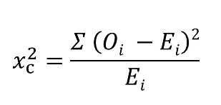

Where

c = Degrees of freedom

O = Observed value

E = Expected value

**Assumptions of Chi-Square Test:**

* **Non-Parametric Nature:**

The Chi-Squared test is a non-parametric, meaning it does not assume any specific distribution of the data. This makes it versatile for various types of the data.

* **Applicability to Categorical Data:**

It’s well-suited for categorical data, where variables are divided into distinct categories rather than continuous measurements.

* **uitable for Small Samples:**

While there are limitations, the Chi-square test, especially Fisher’s exact test, can be used effectively with small sample sizes.

* **Goodness of Fit Test:**

It’s used to test whether observed frequencies match expected frequencies based on a specific distribution, helping to assess model fit.

* **Hypothesis Testing:**

Researchers can use it to test hypothesis about the relationships between variables, aiding in drawing conclusions from data.

**EXPERIMENTAL RESULTS**

**VISUALIZATION OF DATA**

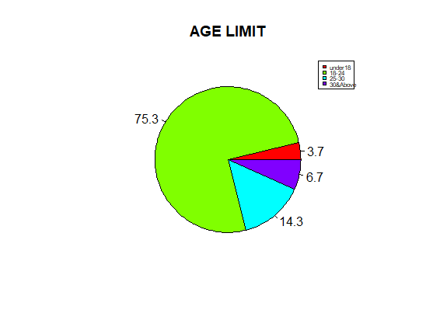

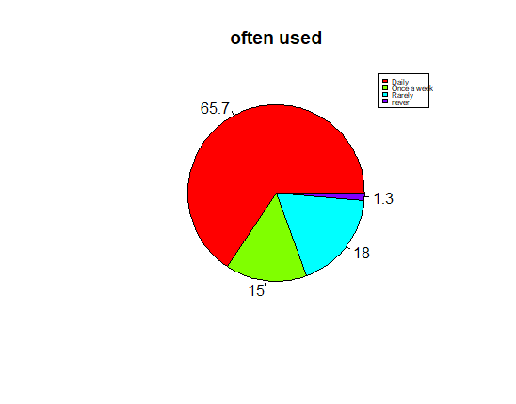In the above chart we can see that highest percentage of 75.3% belongs to 18-24 age group and lowest percentage of 3.7% belongs to Under 18 age group.

In the above chart we can see that most of them use OTT daily with highest percentage of 65.7% and some never use with percentage of 1.3%.

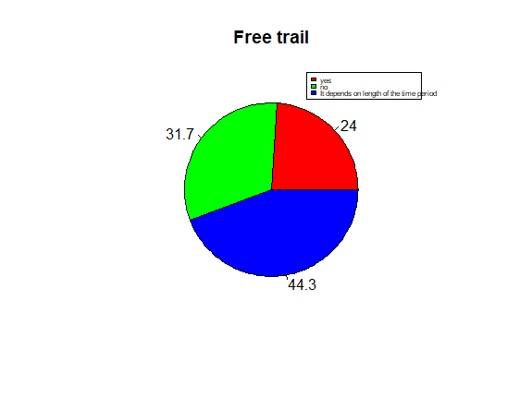

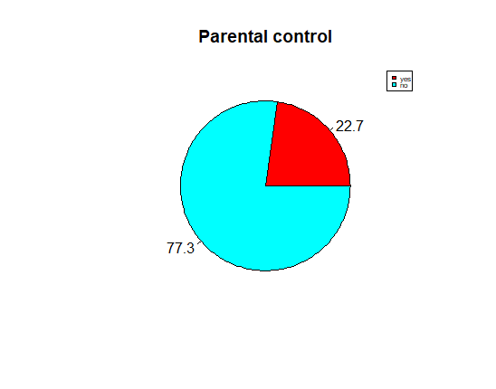In the above chart we can see that many try the free trail when its depends on the length of the time period with 44.3%.

In the above chart 77.3% with highest percentage agreed to have parental control when others with 22.7% doesn’t agree.

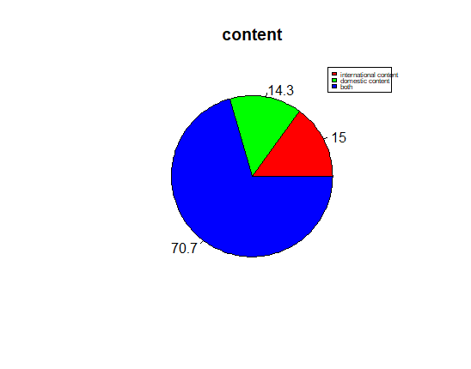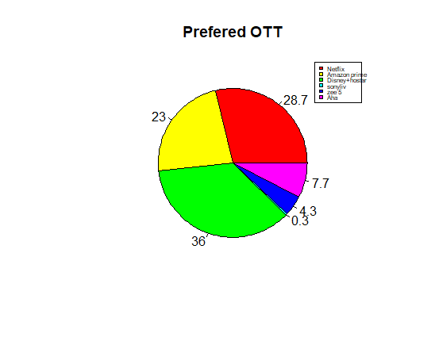

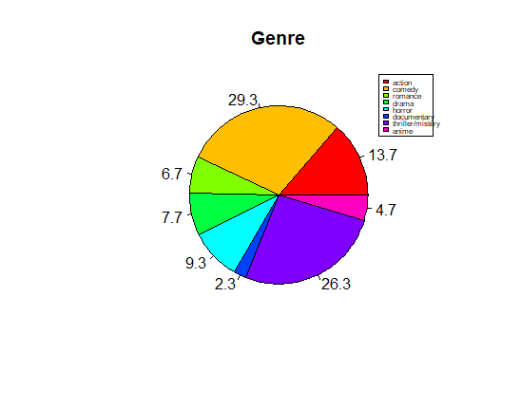In the above chart most people prefer both the internationals and domestic content with 70.7%.

In the above chart the mostly watched genre is COMEDY with 29.3% and least watched genre is DOCUMENTARY with 2.3%.

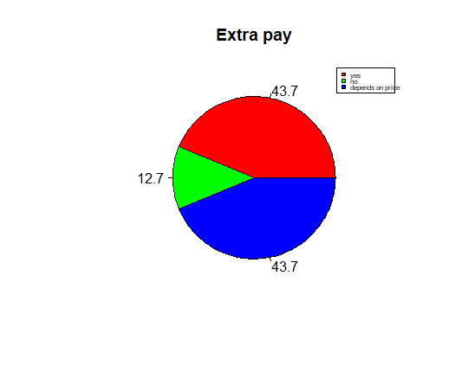

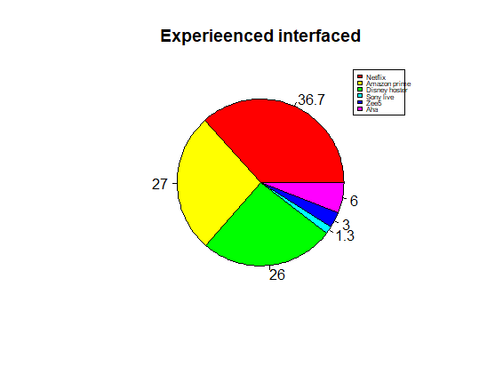

In the above chart NETFLIX provides the best interface with 36.7% and SONY LIV doesn’t provide the best interface with 1.3%.

In the above chart the mostly used OTT is DISNEY+HOTSTAR with 36% and least used OTT is SONY LIV with 0.3%

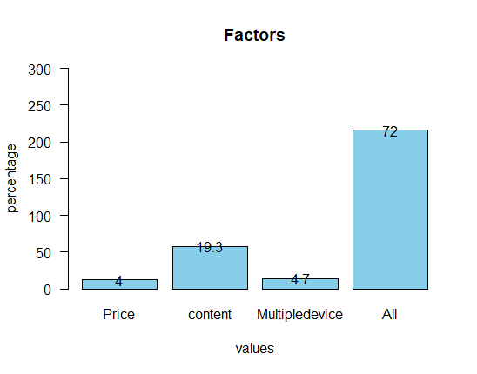

In the above chart the mostly influenced Factor is ALL with 72% and least influenced factor is Price with 4%

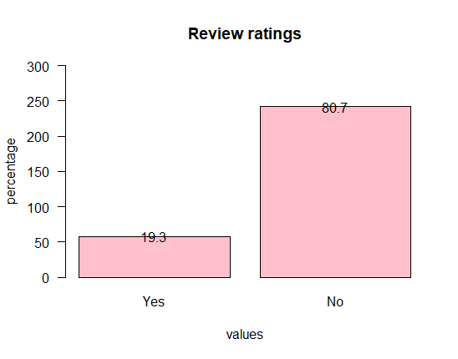

In the above chart 19.3% people prefer user reviews and ratings while subscribing to an online platform.

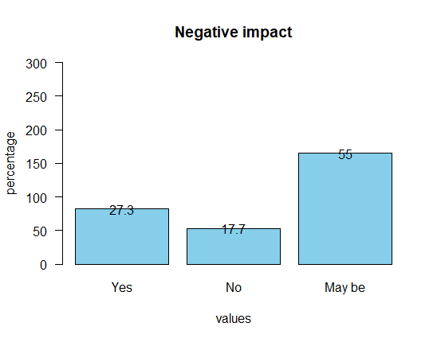

In the above chart 27.3% respondents think OTT platform create negative impact on television/cable services. Remaining 55% think they may create negative impact on the Television.

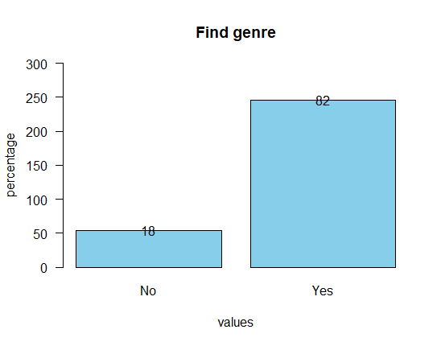

In the above chart 82% of the respondents find it easy to choose a preferred genre in OTT.

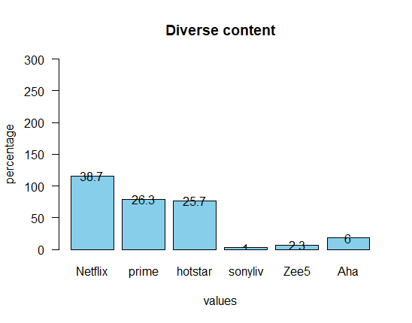

In the above chart 38.7% of the respondents preferred Netflix is the OTT platform offers the most diverse content selection, the next one comes under is Prime 26.3%, the very next one is Disney+hostar 25.7%.

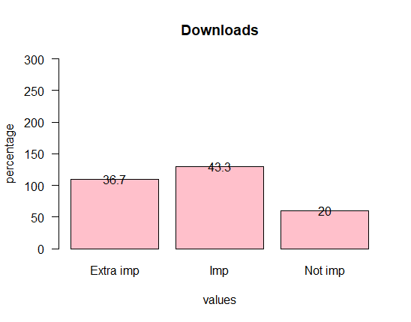

In the above chart 43.3% of the respondents tells it is important the availability of offline viewing/download options on an OTT platform.

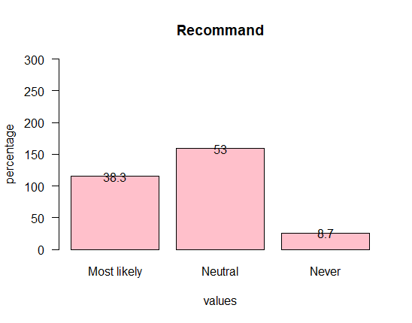

In the above chart 38.3% of the respondents most likely to recommend favourite online platform to others. 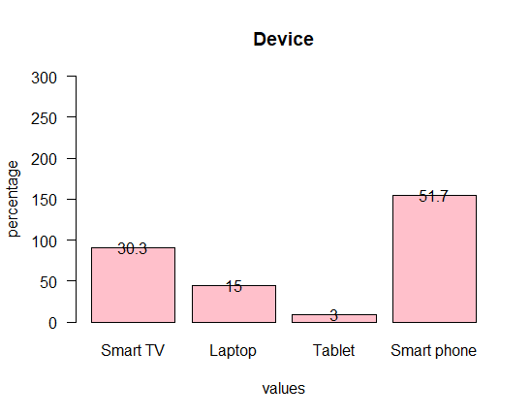

In the above chart 51.7% of respondents prefer Smart phone to watch an OTT platform, 30.3% of respondents prefer Smart Tv to watch an OTT platform.

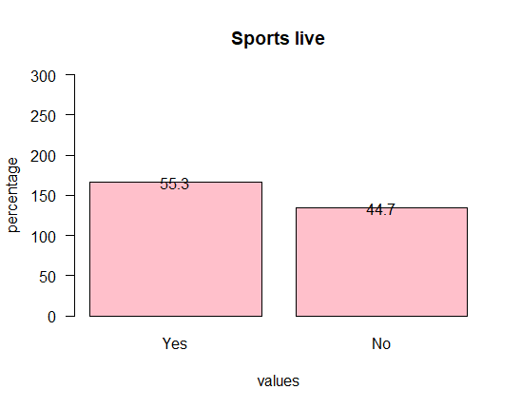

In the above chart 55.3% of respondents subscribe to an OTT platform specifically to watch live sports events.

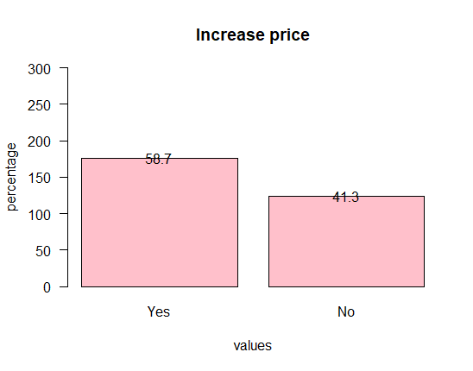

In the above chart 58.7% of respondents will continue using an OTT platform even if it increases subscription price.

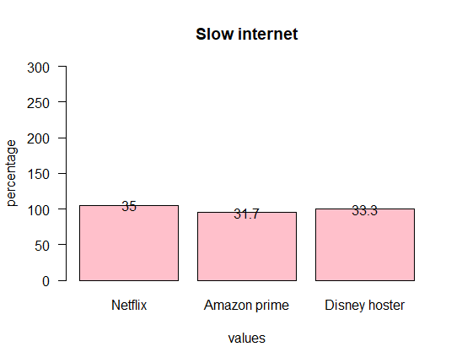

In the above chart 35% of the respondents prefer Netflix is known for its fast and reliable streaming performance even with slower internet connections. 33.3% of respondents prefer Disney+hotstar is the relaiable streaming service.

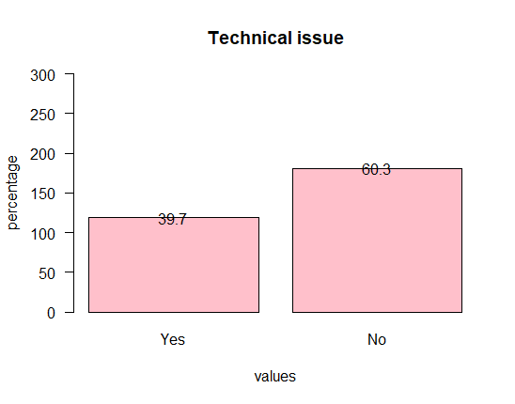

In the above chart 60.3% of respondents never encountered technical issues while using OTT. Remaining 39.7% of respondents encountered technical issues.

**Descriptives and Crosstabulation table**

|  |  |
| --- | --- |
| **Variables** | **Mean ± SD** |
| Often_used | 1.55± 0.830 |
| Free_trail | 2.203±0.802 |
| Parentalcontrol | 1.773±0.419 |
| Review_rating | 1.807±0.395 |
| Factors | 3.447±0.936 |
| Negative impact | 2.277±0.865 |
| Find genre | 1.82±0.384 |
| Diverse content | 2.2±1.348 |
| Preferred OTT | 2.517±1.420 |
| Genre | 4.053±2.406 |
| Extrapay | 2±0.936 |
| Content | 2.557±0.740 |
| Experience interface | 2.25±1.361 |
| Documentries | 2.207±1.335 |
| Downloads | 1.833±0.735 |
| Recommend | 1.79±0.829 |
| Device | 2.76±1.352 |
| Sports live | 1.447±0.497 |
| Increase price | 1.413±0.493 |
| Technical issue | 1.603±0.490 |
| Slow internet | 1.983±0.827 |
| Rating | 4.08±0.892 |

|  |  |  |  |  |  |  |  |  |  |  |  |  |
| --- | --- | --- | --- | --- | --- | --- | --- | --- | --- | --- | --- | --- |
| **s.no** | **VARIABLES** | | **AGE** | | | | | | | | **CHI-SQUARE** | **P VALUE** |
| **Under18** | | **18-24** | | **25-30** | | **30&above** | |
| **F** | **%** | **F** | **%** | **F** | **%** | **F** | **%** |
| 1. | **Factors** | Price | 0 | 0% | 10 | 3.3% | 1 | 0.3% | 1 | 0.3% | 8.2902 | 0.5052 |
| Content | 2 | 0.3% | 43 | 14.3% | 11 | 3.6% | 2 | 0.3% |
| Devices | 0 | 0% | 9 | 3% | 2 | 0.3% | 3 | 1% |
| All the above | 9 | 3% | 164 | 54.6% | 29 | 9.6% | 14 | 4.6% |
| 2. | **Genre** | Action | 2 | 0.6% | 28 | 9.3% | 7 | 2.3% | 4 | 1.3% | 22.98 | 0.345 |
| Comedy | 1 | 0.3% | 66 | 22% | 12 | 4% | 9 | 3% |
| Romance | 0 | 0% | 16 | 5.3% | 3 | 1% | 1 | 0.3% |
| Drama | 0 | 0% | 19 | 6.3% | 3 | 1% | 1 | 0.3% |
| Horror | 4 | 1.3% | 21 | 7% | 2 | 0.6% | 1 | 0.3% |
| Documentary | 1 | 0.3% | 4 | 1.3% | 1 | 0.3% | 1 | 0.3% |
| Thriller | 2 | 0.6% | 62 | 20.6% | 12 | 4% | 3 | 1% |
| Anime | 1 | 0.3% | 10 | 3.3% | 3 | 1% | 0 | 0% |
| 3. | **Diverse**  **content** | Netflix | 8 | 2.6% | 88 | 29.3% | 15 | 5% | 5 | 1.6% | 20.901 | 0.14 |
| Prime | 2 | 0.6% | 60 | 20% | 13 | 4.3% | 4 | 1.3% |
| Hotstar | 0 | 0% | 59 | 19.6% | 11 | 3.6% | 7 | 2.3% |
| Sony live | 0 | 0% | 2 | 0.6% | 0 | 0% | 1 | 0.3% |
| Zee 5 | 1 | 0.3% | 6 | 2% | 0 | 0% | 0 | 0% |
| Aha | 0 | 0% | 11 | 3.6% | 4 | 1.3% | 3 | 1% |
| 4. | **Recommend** | Most likely | 5 | 1.6% | 87 | 29% | 13 | 4.3% | 10 | 3.3% | 4.9501 | 0.5502 |
| Neutral | 5 | 1.6% | 120 | 40% | 24 | 8% | 10 | 3.3% |
| Never | 1 | 0.3% | 19 | 6.3% | 6 | 2% | 0 | 0% |
| 5. | **Increase**  **price** | Yes | 5 | 1.6% | 135 | 45% | 25 | 8.3% | 11 | 3.6% | 1.0139 | 0.7979 |
| No | 6 | 2% | 91 | 30.3% | 81 | 27% | 9 | 3% |

The above table reveals that there was significant among the Age with Factors, Genre, Diverse content, Recommendations and Increase of price of the respondents as all the p values are greater than 0.05(p>0.05).

The above table reveals that there was significant between the Gender with Factors with P value (0.3234) and with Diverse content of respondents with p value (0.8847) which is greater than 0.05(p>0.05), other variables are not significant. Because that there is no association between the Gender related to Genre, Recommendations and Increase in price.

|  |  |  |  |  |  |  |  |  |
| --- | --- | --- | --- | --- | --- | --- | --- | --- |
| S.No | VARIABLES | | GENDER | | | | CHI SQUARE | P-VALUE |
| Female | | Male | |
| F | % | F | % |
| 1. | Factors | Price | 7 | 2.3% | 5 | 1.6% | 3.4798 | 0.3234 |
| Content | 34 | 11.3% | 24 | 8% |
| Devices | 6 | 2% | 8 | 2.6% |
| A.O.B | 141 | 47% | 75 | 25% |
| 2. | Genre | Action | 15 | 5% | 26 | 8.6% | 19.589 | **0.00653** |
| Comedy | 58 | 19.3% | 30 | 10% |
| Romance | 15 | 5% | 5 | 1.6% |
| Drama | 19 | 6.3% | 4 | 1.3% |
| Horror | 17 | 5.6% | 11 | 3.6% |
| Documentary | 3 | 1% | 4 | 1.3% |
| Thriller | 53 | 17.6% | 26 | 8.6% |
| Anime | 8 | 2.6% | 6 | 2% |
| 3. | Diverse  content | Netflix | 75 | 25% | 41 | 13.6% | 1.7331 | 0.8847 |
| Prime | 45 | 15% | 34 | 11.3% |
| Hotstar | 50 | 16.6% | 27 | 9% |
| Sony liv | 2 | 0.6% | 1 | 0.3% |
| Zee 5 | 5 | 1.6% | 2 | 0.6% |
| Aha | 11 | 3.6% | 7 | 2.3% |
| 4. | Recommend | Most likely | 71 | 23.6% | 44 | 14.6% | 5.736 | **0.05681** |
| Neutral | 106 | 35.3% | 53 | 17.6% |
| Never | 11 | 3.6% | 15 | 5% |
| 5. | Increase  price | Yes | 124 | 41.3% | 52 | 17.3% | 10.248 | **0.001368** |
| No | 64 | 21.3% | 60 | 20% |

|  |  |  |  |  |  |  |  |  |  |  |  |  |
| --- | --- | --- | --- | --- | --- | --- | --- | --- | --- | --- | --- | --- |
| S. No | DEMOGRAPHIC VARIABLES | | OCCUPATION | | | | | | | | CHI-SQUARE | P-VALUE |
| Student | | Employee | | Unemployee | | Other | |
| F | % | F | % | F | % | F | % |
| 1. | Factors | Price | 8 | 2.6% | 3 | 1% | 0 | 0% | 1 | 0.3% | 14.439 | 0.1075 |
| Content | 35 | 11.6% | 16 | 5.3% | 3 | 1% | 4 | 1.3% |
| Devices | 5 | 1.6% | 5 | 1.6% | 0 | 0% | 4 | 1.3% |
| A.O. B | 121 | 40.3% | 65 | 21.6% | 18 | 6% | 12 | 4% |
| 2. | Genre | Action | 14 | 4.6% | 18 | 6% | 4 | 1.3% | 5 | 1.6% | 35.77 | 0.0232 |
| Comedy | 49 | 16.3% | 27 | 9% | 6 | 2% | 6 | 2% |
| Romance | 12 | 4% | 4 | 1.3% | 4 | 1.3% | 0 | 0% |
| Drama | 14 | 4.6% | 9 | 3% | 0 | 0% | 0 | 0% |
| Horror | 23 | 7.6% | 2 | 0.6% | 1 | 0.3% | 2 | 0.6% |
| Documentary | 4 | 1.3% | 1 | 0.3% | 1 | 0.3% | 1 | 0.3% |
| Thriller | 41 | 13.6% | 26 | 8.6% | 5 | 1.6% | 7 | 2.3% |
| Anime | 12 | 4% | 2 | 0.6% | 0 | 0% | 0 | 0% |
| 3. | Diverse  content | Netflix | 67 | 22.3% | 38 | 12.6% | 8 | 2.6% | 3 | 1% | 19.192 | 0.2052 |
| Prime | 43 | 14.3% | 24 | 8% | 5 | 1.6% | 7 | 2.3% |
| Hotstar | 45 | 15% | 21 | 7% | 5 | 1.6% | 6 | 2% |
| Sony liv | 2 | 0.6% | 1 | 0.3% | 0 | 0% | 0 | 0% |
| Zee 5 | 6 | 2% | 0 | 0% | 0 | 0% | 1 | 0.3% |
| Aha | 6 | 2% | 5 | 1.6% | 3 | 1% | 4 | 1.3% |
| 4. | Recommend | Most likely | 60 | 120% | 41 | 13.6% | 7 | 2.3% | 7 | 2.3% | 4.6155 | 0.594 |
| Neutral | 96 | 32% | 40 | 13.3% | 11 | 3.6% | 12 | 4% |
| Never | 13 | 4.3% | 8 | 2.6% | 3 | 1% | 2 | 0.6% |
| 5. | Increase  price | Yes | 105 | 35% | 48 | 16% | 12 | 4% | 11 | 3.6% | 2.0209 | 0.5681 |
| No | 64 | 21.3% | 41 | 13.6% | 9 | 3% | 10 | 3.3% |

The above table reveals that there was significant between the occupation and factors, genre, diverse content, recommendations and increase of price of the respondents because p value is greater than 0.05(p>0.05).

**Conclusion**

1. Usage of OTT platform is independent on Age, Gender, Occupation which is widely spread in society.
2. From the descriptives all the options have more influenced to use the OTT platform i.e., All 72% with next Content 19.3% also Factor shows significant difference among all the Gender and Age groups.
   1. Usage of OTT platform does not dependent on Review rating which we already in discussed in visualization.
   2. Most influencing factor for the usage of OTT platform locate in Genre 29.3%
   3. Most rated platform according to the Diverse Content resulted in Netflix platform 38.7%
3. The most popular OTT platform which is recognized is Disney+hotstar shows 36% when compared with Amazon Prime, Sony liv, Zee5, Aha.
   1. The most preferred Genre is comedy in the Age group of (18-24) which fall under student category.
4. To understand the experience of OTT platform the offline viewing download option is important as we seen in visualization. 51.7% people are preferred watching OTT in Smartphones, 58.7% people will continue using an OTT platform if it increases the subscription price.

**REFERENCES**

**REFERENCES**

1. A Proposed Selection Process in Over-TheTop Project Portfolio Management, Jemy Vestius Confido,Dermawan Wibisono, Yos Sunitiyoso, Journal of Industrial Engineering and Management JIEM, 2018 – 11(3): 371- 389 – Online ISSN: 2013-0953 – Print ISSN: 2013-8423 <https://doi.org/10.3926/jiem.2448>

2. Factors influencing the shift from traditional TV to OTT platforms in India, Rohit Jacob Jose, International Journal of Advanced Science and Technology Vol. 29, No. 7s, (2020), pp. 4044-4051.

3. Analysing the impact of COVID-19 on overthe-top media platforms in India, Divya Madnani, Semila Fernandes, Nidhi Madnani, [https://www.emerald.com/insight/1742- 7371.htm](https://www.emerald.com/insight/1742-%207371.htm)

4. Why the networks can’t beat Netflix: speculations on the US OTT Services Market, Eun-A Park, VOL. 19 NO. 1 2017, pp. 21-39, © Emerald Publishing Limited, ISSN 2398- 5038 DIGITAL POLICY, REGULATION AND GOVERNANC, DOI 10.1108/DPRG08-2016-0041.

5. Proliferation of OTT apps in India: an empirical study of OTT apps and its impact on college students, Reshma, Chaitra, IJRAR2001475 International Journal of Research and Analytical Reviews (IJRAR) www.ijrar.org, (E-ISSN 2348-1269, P- ISSN 2349-5138).

6. How Digitization Has Created a Golden Age of Music, Movies, Books, and Television, Joel Waldfogel, The Journal of Economic Perspectives, Summer 2017, Vol. 31, No. 3 (Summer 2017), pp. 195-214, American Economic Association, https://www.jstor.org/stable/44321286 Journal of Positive School Psychology 2022, Vol. 6, No. 3, 7351-7364 7364 http://journalppw.com © 2022 JPPW. All rights reserved.

7. Television’s role in Indian new screen ecology, Smith Mehta, Smith Mehta, Queensland University of Technology, Digital Media Research Centre, z1-515, Musk Ave, Kelvin Grove, QLD 4059, Australia.

8. Exploring Performance Determinants of China’s Cable Operators and OTT Service Providers in the Era of Digital Convergence— From the Perspective of an Industry Platform, Xing Wan, JavierCenamor,andJingChen,Sustainability2017,9,2247;doi:10.3390/su9122247,www.mdpi.c om/journal/sustainability.

9. Television and Globalization: The TV Content Global Value Chain, Jean K. Chalaby, Journal of Communication 66 (2016) 35–59 © 2016 International Communication Association